END LAB TEST
Set 8
- In Google Colab, implement a search algorithm (linear or binary) using ChatGPT’s guidance.
CODE :
def linear_search(arr, target):
for i in range(len(arr)):
if arr[i] == target:
return i # return index
return -1

# Test multiple inputs
arr = [10, 25, 37, 49, 55, 61]

test_values = [25, 61, 100]

for value in test_values:
result = linear_search(arr, value)
if result != -1:
print(f"{value} found at index {result}")
else:
print(f"{value} not found in the list")

OUTPUT:

25 found at index 1
61 found at index 5
100 not found in the list

EXPLAINATION :
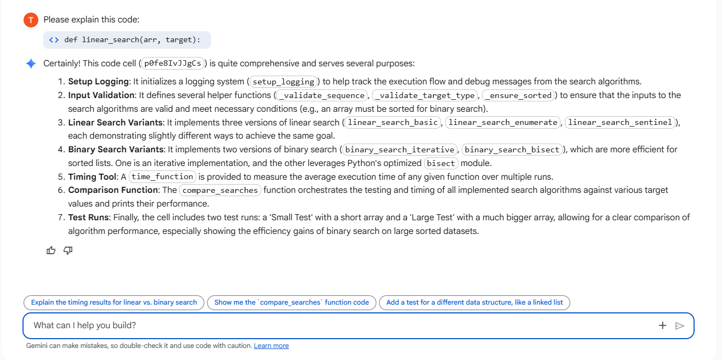

- Use Copilot to add logging, input validation, and optimized versions of the algorithm.

# ===== SETUP LOGGING =====
import logging
from time import perf_counter
from typing import List, Any, Sequence, Optional, Callable, Tuple
import bisect
import random

def setup_logging(level=logging.INFO):
logging.basicConfig(
format="%(asctime)s %(levelname)s: %(message)s",
datefmt="%H:%M:%S",
level=level
)

setup_logging(logging.INFO)
logger = logging.getLogger("search_algorithms")

# ===== INPUT VALIDATION =====
def _validate_sequence(seq: Sequence, name="sequence"):
if seq is None:
raise ValueError(f"{name} cannot be None.")
if not isinstance(seq, (list, tuple)):
raise TypeError(f"{name} must be list or tuple.")
return True

def _validate_target_type(seq: Sequence, target: Any):
if len(seq) == 0:
return True
try:
_ = seq[0] < target
_ = seq[0] > target
except:
raise TypeError("Target is not comparable with list elements.")
return True

def _ensure_sorted(seq: Sequence, name="sequence"):
if any(seq[i] > seq[i+1] for i in range(len(seq)-1)):
raise ValueError(f"{name} must be sorted for binary search.")

# ===== LINEAR SEARCH VARIANTS =====
def linear_search_basic(arr: List[Any], target: Any) -> int:
_validate_sequence(arr)
_validate_target_type(arr, target)
logger.debug("Starting linear_search_basic")

for i, val in enumerate(arr):
if val == target:
logger.info(f"Found {target!r} at index {i}")
return i

logger.info(f"{target!r} not found")
return -1

def linear_search_enumerate(arr: List[Any], target: Any) -> int:
_validate_sequence(arr)
_validate_target_type(arr, target)
logger.debug("Starting linear_search_enumerate")

for i, val in enumerate(arr):
if val == target:
logger.info(f"Found {target!r} at index {i}")
return i

logger.info(f"{target!r} not found")
return -1

def linear_search_sentinel(arr: List[Any], target: Any) -> int:
_validate_sequence(arr)
_validate_target_type(arr, target)
logger.debug("Starting linear_search_sentinel")

if len(arr) == 0:
return -1

a = list(arr)
a.append(target) # sentinel

i = 0
while a[i] != target:
i += 1

if i == len(a) - 1:
logger.info(f"{target!r} not found (sentinel)")
return -1

logger.info(f"Found {target!r} at index {i} (sentinel)")
return i

# ===== BINARY SEARCH VARIANTS =====
def binary_search_iterative(arr: List[Any], target: Any) -> int:
_validate_sequence(arr)
_validate_target_type(arr, target)
_ensure_sorted(arr)

left, right = 0, len(arr)-1
logger.debug("Starting binary_search_iterative")

while left <= right:
mid = (left + right) // 2
if arr[mid] == target:
logger.info(f"Found {target!r} at index {mid}")
return mid
elif arr[mid] < target:
left = mid + 1
else:
right = mid - 1

logger.info(f"{target!r} not found (binary)")
return -1

def binary_search_bisect(arr: List[Any], target: Any) -> int:
_validate_sequence(arr)
_validate_target_type(arr, target)
_ensure_sorted(arr)

idx = bisect.bisect_left(arr, target)
if idx < len(arr) and arr[idx] == target:
logger.info(f"Found {target!r} at index {idx} (bisect)")
return idx

logger.info(f"{target!r} not found (bisect)")
return -1

# ===== TIMING TOOL =====
def time_function(fn: Callable, *args, runs=5):
start = perf_counter()
result = None
for _ in range(runs):
result = fn(*args)
end = perf_counter()

return (end - start) / runs, result

# ===== COMPARISON FUNCTION =====
def compare_searches(arr, targets):
fns = [
linear_search_basic,
linear_search_enumerate,
linear_search_sentinel,
binary_search_iterative,
binary_search_bisect,
]

for t in targets:
print(f"\n========== Target =", t, "==========")
for fn in fns:
try:
avg, result = time_function(fn, arr, t, runs=3)
print(f"{fn.__name__:<25} → index={result}, time={avg:.8f}s")
except Exception as e:
print(f"{fn.__name__:<25} → ERROR: {e}")

# ===== TEST RUN =====
print("=== Small Test ===")
arr = [10, 25, 37, 49, 55, 61]
targets = [37, 10, 90]
compare_searches(arr, targets)

print("\n=== Large Test (for speed comparison) ===")
large = list(range(200000)) # sorted
targets = [0, 99999, 199999, 250000]
compare_searches(large, targets)

OUTPUT:
=== Small Test ===

========== Target = 37 ==========
linear_search_basic → index=2, time=0.00000947s
linear_search_enumerate → index=2, time=0.00000241s
linear_search_sentinel → index=2, time=0.00000360s
binary_search_iterative → index=2, time=0.00000454s
binary_search_bisect → index=2, time=0.00000369s

========== Target = 10 ==========
linear_search_basic → index=0, time=0.00000144s
linear_search_enumerate → index=0, time=0.00000114s
linear_search_sentinel → index=0, time=0.00000143s
binary_search_iterative → index=0, time=0.00000245s
binary_search_bisect → index=0, time=0.00000187s

========== Target = 90 ==========
linear_search_basic → index=-1, time=0.00000161s
linear_search_enumerate → index=-1, time=0.00000133s
linear_search_sentinel → index=-1, time=0.00000152s
binary_search_iterative → index=-1, time=0.00000243s
binary_search_bisect → index=-1, time=0.00000179s

=== Large Test (for speed comparison) ===

========== Target = 0 ==========
linear_search_basic → index=0, time=0.00000595s
linear_search_enumerate → index=0, time=0.00000239s
linear_search_sentinel → index=0, time=0.00280883s
binary_search_iterative → index=0, time=0.02435807s
binary_search_bisect → index=0, time=0.01900636s

========== Target = 99999 ==========
linear_search_basic → index=99999, time=0.00527975s
linear_search_enumerate → index=99999, time=0.00531580s
linear_search_sentinel → index=99999, time=0.00604259s
binary_search_iterative → index=99999, time=0.01951954s
binary_search_bisect → index=99999, time=0.01885169s

========== Target = 199999 ==========
linear_search_basic → index=199999, time=0.01051049s
linear_search_enumerate → index=199999, time=0.01067975s
linear_search_sentinel → index=199999, time=0.01060930s
binary_search_iterative → index=199999, time=0.01905331s
binary_search_bisect → index=199999, time=0.02022154s

========== Target = 250000 ==========
linear_search_basic → index=-1, time=0.01142831s
linear_search_enumerate → index=-1, time=0.01070580s
linear_search_sentinel → index=-1, time=0.01112624s
binary_search_iterative → index=-1, time=0.01896924s
binary_search_bisect → index=-1, time=0.01996146s

EXPLAINATION:
